 S  2-4-2013PPMDivision PIMWindmeijer, drs H.J.M.Installation guide robot tool CPItatistics Netherlands

Division PIM

PPM

P.O.Box 24500

2490 HA The Hague

The Netherlands

**User guide robot tool CPI**

Internet Robots project Statistics Netherlands

Version v2.00, 14-11-2014

[1. Main screen 2](#_Toc402428276)

[1.1 Editing product groups 2](#_Toc402428277)

[1.2 Editing respondents 2](#_Toc402428278)

[1.3 Editing the XPath expressions of a respondent 2](#_Toc402428279)

[1.4 Editing Price and Price context 3](#_Toc402428280)

[2. Product group 3](#_Toc402428281)

[2.1 New 3](#_Toc402428282)

[2.2 Editing 4](#_Toc402428283)

[2.3 Deleting 4](#_Toc402428284)

[2.4 Importing configuration 4](#_Toc402428285)

[2.5 Exporting configuration 4](#_Toc402428286)

[3. Respondents 5](#_Toc402428287)

[3.1 New 5](#_Toc402428288)

[3.2 Editing 5](#_Toc402428289)

[3.3 Deleting 6](#_Toc402428290)

[3.4 Copying 6](#_Toc402428291)

[3.5 Selecting columns 6](#_Toc402428292)

[4. Respondent – XPath 8](#_Toc402428293)

[4.1 New 8](#_Toc402428294)

[4.2 Editing 8](#_Toc402428295)

[4.3 Deleting 9](#_Toc402428296)

[4.4 Showing price context 9](#_Toc402428297)

[5. Price and Price context 10](#_Toc402428298)

[5.1 Collecting new price info for a product group 10](#_Toc402428299)

[5.2 Examining Price en Price context 11](#_Toc402428300)

[5.3 Taking the price from the previous response 11](#_Toc402428301)

[5.4 Collecting/changing price info respondent 11](#_Toc402428302)

[5.5 Exporting prices 13](#_Toc402428303)

[Annex A: record description export file 14](#_Toc402428304)

[Annex B: Known problems 15](#_Toc402428305)

[Annex C: XPath expressions – how do I make them? 15](#_Toc402428306)

# Main screen

You start the robot tool by executing the file “robottool.bat”. You find this file in the root map of the robot tool. After the start of the robot tool you see the following screen:

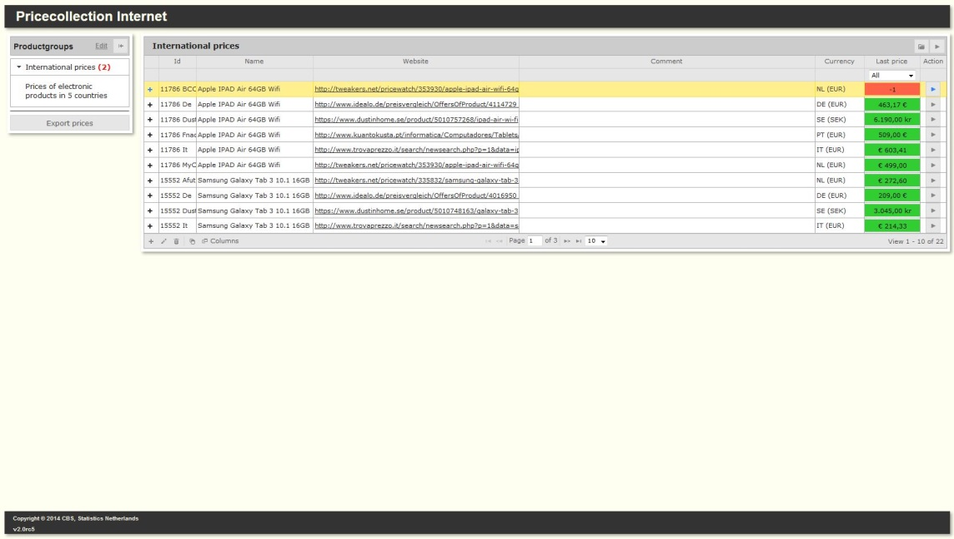Screen 1

## Editing product groups

The robot tool serves to gather the price of respondents of the various product groups. The left-hand column shows all product groups. You can edit the product groups by clicking on “change” (see screen 1, left-hand column): see chapter 2. The red figure between parentheses behind a product group indicates the number of respondents in that product group for whom no price is known yet (price=-1). By clicking on a product group the respondents belonging to that product group are retrieved and shown in the right hand section of the screen.

## Editing respondents

Each product group can have several respondents. For editing the respondents of a product group: see chapter 3.

## Editing the XPath expressions of a respondent

To retrieve the price context for a respondent from the internet you have to link one or several XPath expressions with that respondent. By clicking onicn_ShowXPath for a respondent (see screen 1) you can edit the XPath expressions of that respondent: see chapter 4.

## Editing Price and Price context

You can use the XPath expressions belonging to a respondent to retrieve the price context for that respondent from the internet. For editing the price and price context: see chapter 5.

# Product group

The screen below is the basic screen for editing product groups (see chapter 1.1)

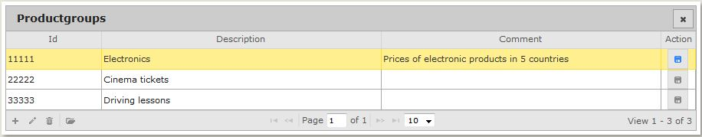

Screen 2

NB: In these kinds of tables the number of lines shown can be changed by clicking the downward arrow: 

## New

You can add a new product group by clicking on icon icn_Add (see screen 2).

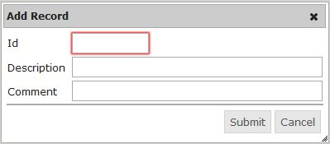

Screen 2.1

## Editing

You can edit an existing product group editing by clicking on icon icn_Edit (see screen 2).

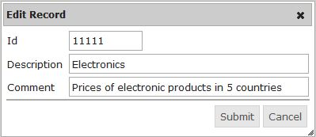

Screen 2.2

## Deleting

You can delete an existing product group by clicking on icon icn_Delete (see screen 2).

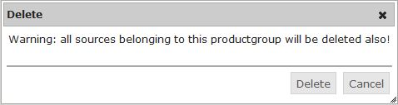

Screen 2.3

## Importing configuration

You can import an existing configuration (i.e. a product group with its respondents and XPath expressions) by clicking on icon icn_ImportConfig (see screen 2).

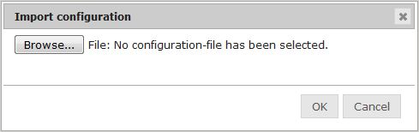

Screen 2.4

You can select a previously saved configuration file (extension “csv”) by using “Browse”. For specifications see annex 2.

## Exporting configuration

You can create a configuration file by clicking on icon icn_ExportConfig (see screen 2).

Nb. You can determine in which map you save the configuration file by using the “config.json” file in the root map of the robot tool.

# Respondents

The main screen below is the basic screen for editing respondents (see chapter 1.2)

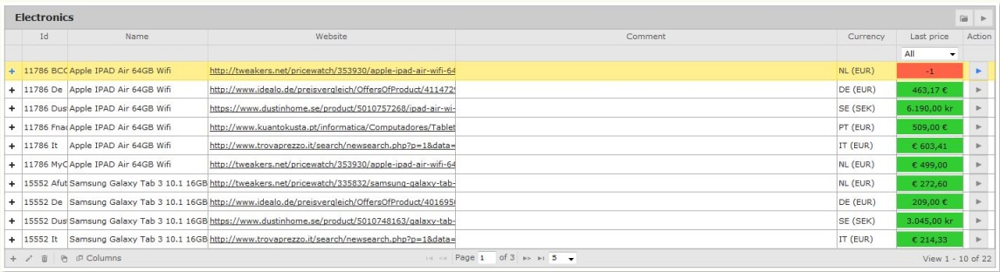

Screen 3

## New

You can add a new respondent by clicking on icon icn_Add (see screen 3, below).

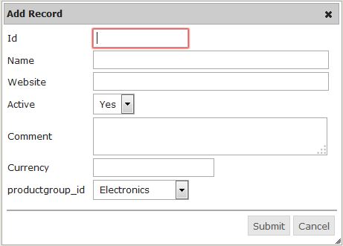

Screen 3.1

In general it is possible to retrieve prices for a respondent. The respondent is active (Active = Yes). However collecting prices for a respondent may become impossible after a while (e.g. the respondent has stopped the activities or the prices cannot be retrieved for technical reasons). You can switch the respondent to inactive (Active = No). No more prices will be retrieved for this respondent.

## Editing

You can edit a respondent by clicking on icon icn_Edit (see screen 3).

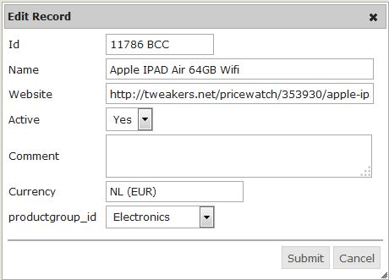

Screen 3.2

## Deleting

You can delete a respondent by clicking on icon icn_Delete ( see screen 3).

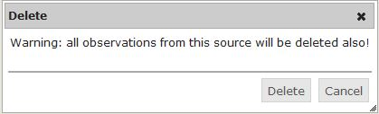

Screen 3.3

## Copying

You can copy a respondent by clicking on icon icn_CopyBerichtgever (see screen 3).

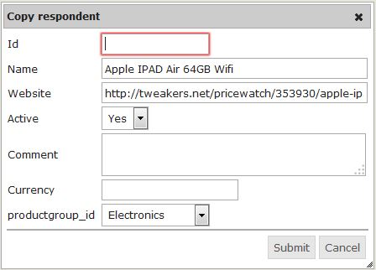

Screen 3.4

## Selecting columns

You can indicate which columns you want to see in screen 3. By clicking on icon  ( see screen 3) you will get the following screen.

The tick in front of the name of the column means that the column is shown. The columns ‘Id’, ‘Name’, ‘Website’, ‘Last Price’ and ‘Action’ are always shown.

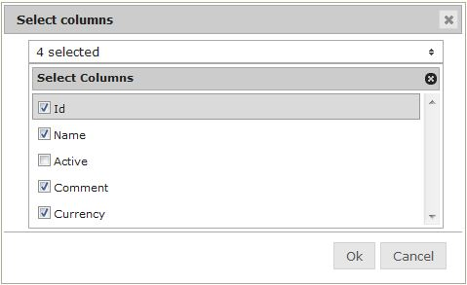

Screen 3.5

# Respondent – XPath

The following screen is the basic screen for editing the XPath expressions of a respondent (see chapter 1.3).



Screen 4

## New

You can add a new XPath expression by clicking on icon icn_Add (see screen 4). A step number is automatically generated that is one up from the largest number of steps existing for this respondent. The step number can be changed but cannot be the same as another step number.

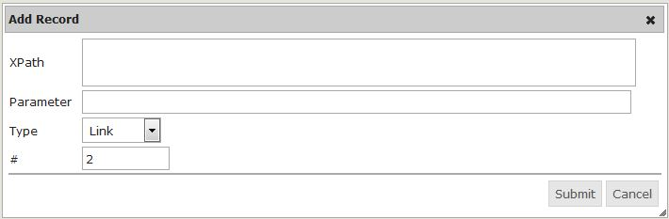

Screen 4.1

You can choose from 4 types of paths: Link (L), Input (I), Submit (S) and Context (C).

Link: Simulates a mouseclick on the selected element in the webpage.

Input: Simulates inserting text into the selected input element of the webpage. This text is taken from the *Parameter* field.

Submit: Simulates submitting the webform of the selected webform element.

Context: Grabs the text part of the selected web element.

## Editing

You can edit an XPath expression by clicking on icon icn_Edit (see screen 4).

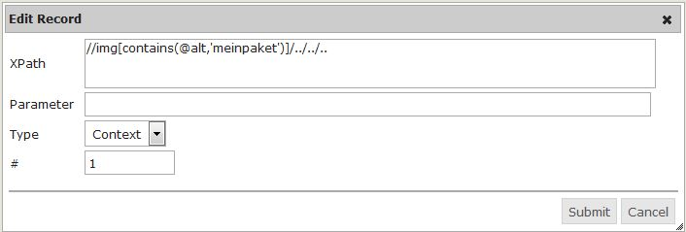

Screen 4.2

## Deleting

You can delete an XPath expression by clicking on icon icn_Delete (see screen 4).

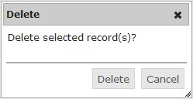

Screen 4.3

## Showing price context

There are two options for testing the XPath expressions:

1. Click on icon icn_ShowInternetpage (see screen 4, column “Action”)  
   You will see the internet page of the respondent to which the XPath expression is applied.
2. Click on icon icn_ShowPricecontext (see screen 4, column “Action”)  
   You will see that part of the respondent’s web page to which the XPath expression is applied. If you have clicked on the icon in the last line then that is the price context. If the price context could not be retrieved that the screen shows an error message, see also paragraph 5.1.

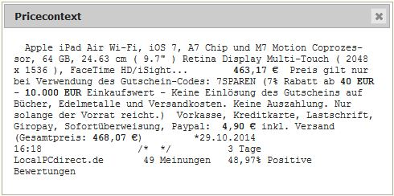

Screen 4.5

# Price and Price context

The following screen is the basic screen for editing price and price context (see chapter 1.4).



Screen 5

## Collecting new price info for a product group

By clicking on icon icn_GetPriceInfo (see screen 5, top right-hand corner) you can retrieve the price (and price context) for all respondents of the product group from the internet and save it as a new observation. It is saved under the date on which you saved the observation. If you succeeded in collecting the price context for a respondent and the price context is the same as in the previous observation, then the price of the previous observation is taken and shown against a green background (see screen 1, column “Last price”). If the price context changed or if the collection of the price context failed for a respondent, the price = “-1” is shown against a red background. If the collection of the price info failed, an error message with the reason is saved in the price context:

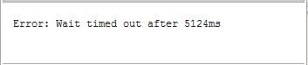

At the end you receive the following message:

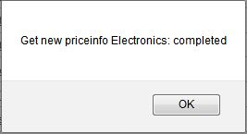

The new observations are recorded in the database. The application (see screen 5) shows the new observations.

## Examining Price en Price context

By clicking on price (or “-1”) of a respondent (see screen 5, column “Last price”) you can examine the price and its price context of the observations (up to five of the latest) of the respondent.

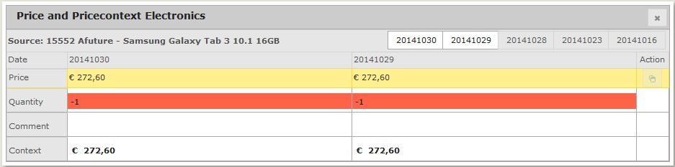

Screen 5.2a

The default shows the two most recent observations. By clicking on the tabs (screen 5.2a, top right-hand) you can show and hide the observations.

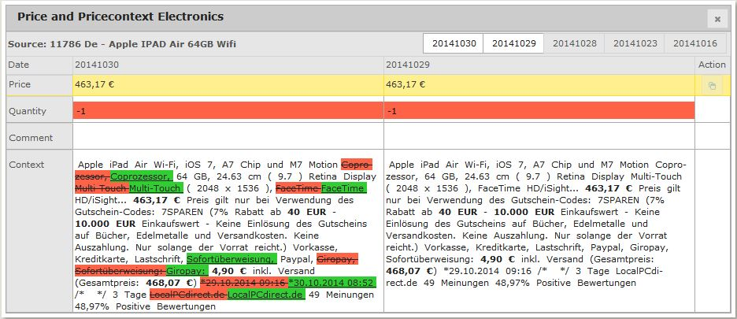

Screen 5.2b

If collecting the price context failed or if the price context has changed, you can adjust the price by clicking on the field behind “Price” (see screen 5.2b). You can also add a remark by clicking on the field behind “Remark” (see screen 5.2b). This can only be done with the most recent observation.

## Taking the price from the previous response

Apart from adjusting the price of the last observation by hand (see 5.2) you can also take the price from the previous observation of the respondent. You can do this by clicking on the icon icn_CopyPrice (see screen 5.2b, column “Action”). You can only use this when no price has been entered yet (price = -1).

## Collecting/changing price info respondent

If the price context of a respondent has changed (e.g. the price is in a different place on the respondent’s website) then you may have to change the XPath expressions (see chapter 4). If collecting the price context failed, you can collect the price context of a respondent collecting by clicking on icon icn_GetPriceInfo_one (see screen 5, column “Action”).

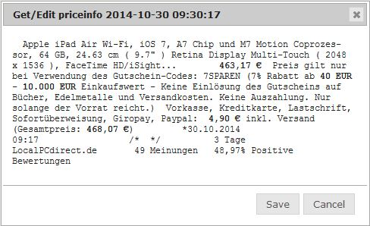

Screen 5.4

By clicking on “Save” you save the price and price context of the last observation of the respondent in the database, overwriting the old values.

## Exporting prices

By clicking on “Export prices” (see screen 1, left-hand column) you can export the most recently observed price information of all active respondents of all product groups. By clicking on the icon icn_ExportPrices (see screen 5, top right-hand corner) you can export the most recently observed price information of all active respondents of one product group. Depending on your choice of exporting, you can tick all product groups or just one product group. You can change your selection.

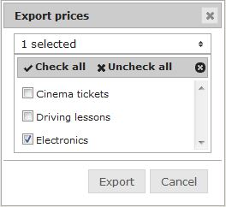

Screen 5.5

NB. You can select the map in which you save your export file by using the file “config.json” in the root map of the robot tool.

# Annex A: record description export file

|  |  |
| --- | --- |
| **Naam** | **Omschrijving** |
| **p**roduct **group** | Identification of the product group |
| **source** | Identification of the respondent |
| **observation\_date** | Date/time of the observation |
| **value** | Observed price |
| **quantity** | Observed quantity |
| **comment** | Any comment on the observation |
| **context** | Observed price context |
| **user\_id** | The PID of the observer |

# Annex B: Known problems

* While moving a dialog such as screen 5.5, the list of choices will disappear. You can make it visible again by pressing the arrow on the top right corner.

# Annex C: XPath expressions – how do I make them?

ToDo